Logic Gates and Digital Circuits Name:

**What is a logic gate?** It is an elementary building block of a _____.

Most standard logic gates have two __________ and one ______________.

**What is a truth table?** A chart of a circuit's’ inputs and outputs is called its Truth Table.

* A ___________ indicates off. A _______ indicates on.
* In order to help you predict the output of complex circuits, truth tables often have mid-values (see complex circuits later in the assignment) indicated by letters.

**Rules**

And - If **ALL** inputs are on, the output is on. If even one input is off, the output is off.

Not - Reverses the input

Or - If **ANY** inputs are on, the output is on.

**Part 1: And, Or & Not**

* Your job is to fill in the truth tables for all of the gates and circuits below.
* Try to do this first page from memory first. Then correct your answers using Logic Lab.

| And Gate     | **A** | **B** | **X** | | --- | --- | --- | | 0 | 0 | 0 | | 0 | 1 | 0 | | 1 | 0 | 0 | | 1 | 1 | 1 |   Not Gate     | **B** | **X** | | --- | --- | | 0 | 1 | | 1 | 0 |   Part 2 - Complete others using Logic Lab  This is to be completed with the help of: <http://www.neuroproductions.be/logic-lab/> | Or Gate     | **A** | **B** | **X** | | --- | --- | --- | | 0 | 0 | 0 | | 0 | 1 | 1 | | 1 | 0 | 1 | | 1 | 1 | 1 | |
| --- | --- | --- | --- | --- | --- | --- | --- | --- | --- | --- | --- | --- | --- | --- | --- | --- | --- | --- | --- | --- | --- | --- | --- | --- | --- | --- | --- | --- | --- | --- | --- | --- | --- | --- | --- | --- | --- |
| Nand Gate     | **A** | **B** | **X** | | --- | --- | --- | | 0 | 0 | 1 | | 0 | 1 | 1 | | 1 | 0 | 1 | | 1 | 1 | 0 | | Nor Gate     | **A** | **B** | **X** | | --- | --- | --- | | 0 | 0 | 1 | | 0 | 1 | 0 | | 1 | 0 | 0 | | 1 | 1 | 0 |   XOR Gate     | **A** | **B** | **X** | | --- | --- | --- | | 0 | 0 | 0 | | 0 | 1 | 1 | | 1 | 0 | 1 | | 1 | 1 | 0 | |

**Combining Logic Gates into Complex Circuits**

1) (NOT & AND gate)



| **A** | **B** | **Y** | **Z** |
| --- | --- | --- | --- |
| 0 | 0 | 1 | 0 |
| 0 | 1 | 0 | 0 |
| 1 | 0 | 1 | 1 |
| 1 | 1 | 0 | 0 |

2) (NOT & AND & AND gate)

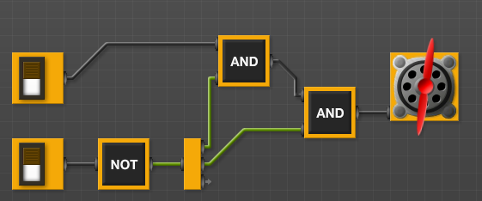

| **A** | **B** | **X** | **Y** | **Z** |
| --- | --- | --- | --- | --- |
| 0 | 0 | **1** | **0** | 0 |
| 0 | 1 | **0** | 0 | 0 |
| 1 | 0 | 1 | 1 | 1 |
| 1 | 1 | 0 | 0 | 0 |

3) (AND & AND & OR)



| **A** | **B** | **C** | **D** | **X** | **Y** | **Z** |
| --- | --- | --- | --- | --- | --- | --- |
| 0 | 0 | 0 | 0 |  |  |  |
| 0 | 0 | 0 | 1 |  |  |  |
| 0 | 0 | 1 | 0 |  |  |  |
| 0 | 0 | 1 | 1 |  |  |  |
| 0 | 1 | 0 | 0 |  |  |  |
| 0 | 1 | 0 | 1 |  |  |  |
| etc. | That’s enough. You get the idea. |  |  |  |  |  |

D) Draw your own and come up with a truth table (or trade it with a neighbour to complete each other’s truth table). Give your circuit:

* 2 or 3 inputs
* 2 or 3 different kinds of gates (using only AND, NOT & OR)

Circuit Drawing

How? Create something new in Logic Lab and then use the Snipping Tool to get a screenshot. (Start menu… Snipping tool)

Truth Table